Dalton Murray

Systems Analysis and Design

INT 6123 – Systems Analysis and Design

Dr. Andrew Makar

November 27, 2023

**IA #12 Spring Breaks R Us**

**Question 6 - Draw a UML design class that shows the following information:**

**The class name is Boat, and it is a concrete entity class. All three attributes are private strings with initial null values. The attribute boat identifier has the property of “key.” The other attributes are the manufacturer of the boat and the model of the boat. There is also an integer class-level attribute containing the total count of all boat objects that have been instantiated. Boat methods include creating a new instance; updating the manufacturer; updating the model; and getting the boat identifier, manufacturer, and model year. There is a class-level method for getting the count of all boats.**

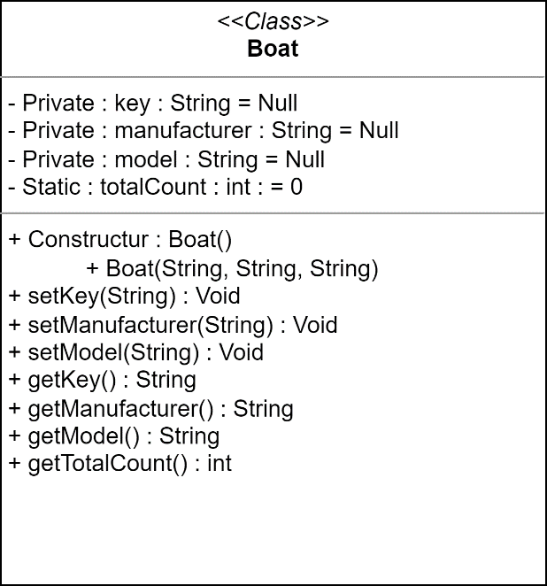

PDF: Attached separately

**References**

Satzinger, J. W., Jackson, R. B., & Burd, S. D. (2016). Systems analysis and design in a Changing World (7e ed.). Cengage Learning.

I have neither given nor received unauthorized aid in completing this work, nor have I presented someone else's work as my own.

*Dalton Murray*